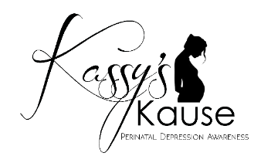 Postpartum Support International Scholarship Application

Deadline to submit application: June 30, 2021.

Kassy’s Kause is accepting now applications for a $100.00 scholarship to be used towards the registration of the Postpartum Support International training September 8 & 9, 2021 in Albuquerque, New Mexico 6 scholarships will be awarded. Please complete the following information and email to kassykausepresident@gmail.com no later than June 30, 2021.

First/Last name: | Email: | Company/organization:  Position:
Mailing address:  City:  State: Zip: | Phone  ( ) | How did you hear about this scholarship?
Please circle all that  apply:  Parent  Grandparent  Student  Counselor  Therapist (specialty): _________________ | Social Worker  Home Visitor  Parent Educator  Medical Professional  Nurse  Doctor  Other: | Tell us how you can use the information from the training.
Can you share your experience if any with Maternal Mental health? |  | Have you or someone you know experienced prenatal or postpartum depression if yes please share what you feel comfortable sharing. Please do not mention names.
Official use only: | Date Received: | Board member(s):

